GIRIJANANDA CHOWDHURY INSTITUTE OF MANAGEMENT AND TECHNOLOGY, GUWAHATI, ASSAM



INTERNSHIP REPORT
On
“Stock Price Prediction using Sentiment Analysis”
Submitted for partial fulfillment
Of
5th Semester of Bachelor of Technology
SESSION: 2021-2025
DEPARTMENT OF
COMPUTER SCIENCE AND ENGINEERING



ASSAM SCIENCE AND TECHNOLOGY UNIVERSITY, GUWAHATI
SUBMITTED BY:
Sagar Choudhury (210310007045)

(Duration: 21st July 2023 to 20th September 2023)

GIRIJANANDA CHOWDHURY INSTITUTE OF MANAGEMENT AND TECHNOLOGY, GUWAHATI, ASSAM


CERTIFICATE

This is to certify that the Academic Internship Training entitled “Stock Price Prediction using Sentiment Analysis” being submitted by SAGAR CHOUDHURY in partial fulfillment of requirement for the award of the degree of BACHELOR OF TECHNOLOGY (B. Tech) from GIRIJANANDA CHOWDHURY INSTITUTE OF MANAGEMENT AND TECHNOLOGY, ASSAM.
She has worked under the supervision of. The report submitted is genuine and no part of the report has been submitted anywhere for the award of any degree from any university.

Dr. Minakshi Gogoi
Head of the Department
Department of Computer Science and Engineering, GIMT, GHY- 17

GIRIJANANDA CHOWDHURY INSTITUTE OF MANAGEMENT AND TECHNOLOGY, GUWAHATI, ASSAM

ACKNOWLEDGEMENT

The internship opportunity at IIT GUWAHATI was a great opportunity for learning and professional development. So, I feel very lucky to have the opportunity to be a part of this journey. In view of the former, I would like to take this opportunity to express my deep gratitude and special gratitude to Mr. Prithwijit Guha for giving me the opportunity to work under him, Mrs. Meenakshi Gogoi for referring us to Mr. Prithwijit Guha. And my internship coordinators Meghali Deka and Pankaj Chaudhary, despite being extremely busy with their duties, took the time to listen to me, guide me, and keep me on track. It allowed me to execute my project under a respected organization. I consider this opportunity a major milestone in my professional development. I will make the most of the skills and knowledge I have acquired and strive for self-improvement to achieve my professional goals.

SUBMITTED BY:
Sagar Choudhury (210310007045)

CONTENTS

- INTRODUCTION
- OBJECTIVE
- DATASET
- METHODOLOGY
  - Data collection and Slicing
  - Preprocessing
  - Sentimental Scores
  - Creating the Machine learning Model
  - Evaluation Metric
- SYSTEM SPECIFICATIONS
  - Hardware used
  - Software used
- OUTPUT
  - Key Findings
  - Limitations
  - Practical Implications and Future Scopes
- CONCLUSION

- INTRODUCTION
In the fields of natural language processing (NLP) and artificial intelligence, sentiment analysis, commonly referred to as opinion mining, is the methodical examination of text to ascertain the sentiments, opinions, or emotions conveyed within it. Understanding the text's subjective content and classifying it as positive, negative, or neutral is the aim. Sentiment analysis is important for applications including measuring public opinion, assessing customer feedback, and detecting sentiment patterns in diverse fields. It does this by using machine learning algorithms and linguistic techniques to extract insights from large amounts of textual data.
In the finance world, predicting stock prices in the ever-changing world of financial markets has always been a difficult but vital task for traders, investors, and financial experts. To predict market movements, traditional methods frequently rely on quantitative models, technical analysis, and fundamental variables.
Stock price prediction using sentimental analysis works on the historical top news headlines on the subject company (Dow Jones Industries). The collected news headlines are from year 2008 to 2016 , and the stock prices respective to the date on the headlines. The project first signifies each headlines and gives its sentiment scores on positive, negative and neutral sentiments. Then a Machine Learning algorithm known as the Linear Discriminant algorithm draws comparison using the feature and target datasets of the sentiment scores and tries to predict the stock prices on each date.
Some of the real life implications on the financial world of this model are :
- Investors can leverage sentiment analysis to gauge market sentiment and make informed decisions about buying or selling stocks.
- Sentiment analysis can help in assessing the level of risk associated with particular stocks or the market as a whole.
- Traders can incorporate sentiment analysis into algorithmic trading strategies to automate decision-making processes. Algorithms can respond to shifts in sentiment, executing trades based on predefined rules and models.
- Sentiment analysis serves as an early warning system, alerting investors to shifts in public perception that may precede significant market movements. This allows for timely adjustments to investment strategies.

- OBJECTIVE

The primary objective of this report is to conduct a comprehensive analysis of sentiment in the context of stock price prediction. Through the integration of sentiment analysis methodologies and techniques, the report aims to achieve the following:
- Evaluate the impact of news reports on the stock prices. The sentiments expressed in financial news influence stock prices. Assess the correlation between positive, negative, and neutral sentiments and subsequent market movements.
- Evaluate the effectiveness and accuracy of sentiment analysis models in capturing and interpreting market sentiments.
- Investigate how sentiment analysis can enhance traditional stock price prediction models. Explore methodologies for integrating sentiment-derived insights into predictive algorithms to improve forecasting accuracy.
- Offer insights and recommendations based on the findings of sentiment analysis. Provide actionable information for investors, traders, and financial professionals to make more informed and strategic decisions in the stock market.
- Discovering and analyzing different Machine Learning algorithms that fit the best to find such prediction and give the most accurate predictions on the stock price patterns .

- DATASET

There are two datasets used in this project. The two datasets are information on the Dow Jones Industry. The two datasets are:
- The first dataset contains the top 25 news headlines related to the Dow jones Industry collected from various sources. The headlines are labeled date-wise. The date ranges from year 2008 to 2016. The dataset also contains a column termed as “Label” which tells us whether the stock price on the particular date increased or decreased. ‘0’ meant the stock price went down and ‘1’ meant the stock price went up.
- The second dataset contains the stock information on the organization’s stock prices. It has the open, high, close, volume etc. columns containing the stock values on the particular date . the information is collected from Yahoo Finance and has Information ranging from the same dates in the first dataset making it easy to compare. The columns mentioned are :
        - Open: The price of the financial instrument at the beginning of a trading period (e.g., a day).
        - High: The highest price reached by the financial instrument during the trading period.
        - Low: The lowest price reached by the financial instrument during the trading period.
        - Close: The price of the financial instrument at the end of the trading period.
        - Adj Close: The adjusted closing price reflects the stock's value after accounting for any corporate actions (such as dividends, stock splits) that may affect its price.
        - Volume: The number of shares (or contracts) traded during the given period.

- METHODOLOGY

  - DATA COLLECTION AND SLICING
- Foremostly the required libraries are installed and imported to the project to perform the sentiment analysis and machine learning algorithm. These include :
- Pandas
- Numpy
- Re
- Textblob
- VADER Sentiment
- Sklearn(model_selection, metrics, discriminant_analysis)

- The datasets are imported to the code session and initialized and merged into one dataset.
- The headlines are sliced out of the first dataset for finding its sentiment of each
4.2 PRE-PROCESSING
- The sliced out headlines are pre-processed by removing the unwanted characters and the cleaned headlines are merged to the merged dataset.

  - SENTIMENT SCORES

- Before finding the sentiment scores, the subjectivity and the polarity of each headline is found out . this is done by the library TextBlob. TextBlob is a Python library for processing textual data. It provides a simple API for diving into common natural language processing (NLP) tasks such as part-of-speech tagging, noun phrase extraction, sentiment analysis etc. The values calculated from the headlines are:
    - Subjectivity: It measures the degree of subjective or objective sentiment in a text. The subjectivity value ranges from 0 to 1, where 0 indicates an objective (or factual) statement, and 1 indicates a highly subjective statement.
    - Polarity: It measures the degree of positive or negative sentiment in a text. The polarity value ranges from -1 to 1, where -1 indicates a highly negative sentiment, 0 indicates a neutral sentiment, and 1 indicates a highly positive sentiment.

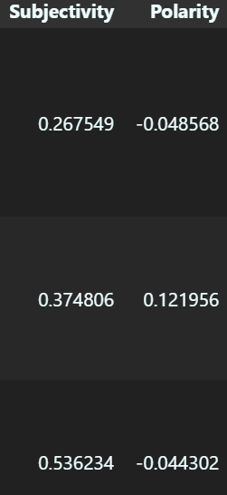
Fig (a) Subjectivity and Polarity of the first three rows of headlines.
- Then the Sentimental scores are found out using the VADER Sentiment library. VADER (Valence Aware Dictionary and Sentiment Reasoner) is a pre-built sentiment analysis tool designed for analyzing text sentiment in English. It is part of the NLTK (Natural Language Toolkit) library in Python. Here the compound, positive, neutral, negative sentiment scores of the headlines are calculated. The compound score is the sum of the all the polarity scores which ranges from -1(most negative) to 1(most positive).
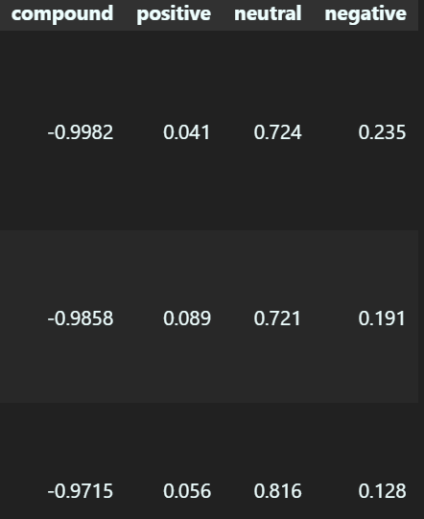

Fig (b) Polarity scores of the first 3 headlines rows .

  - CREATING THE MACHINE LEARNING MODEL

- To make the ML model, we need to select the numeric columns i.e. ‘['Open','High','Low','Volume', 'Subjectivity', 'Polarity', 'compound', 'positive', 'neutral', 'negative', 'Label'] from the merged dataset and make a new dataset with the selected columns .
- Split the dataset into train and test datasets.
- The algorithm used to train the model is the Linear Discriminant Analysis. The linear Discriminant Analysis is a generalization of Fisher's linear discriminant, a method used in statistics and other fields, to find a linear combination of features that characterizes or separates two or more classes of objects or events.

  - EVALUATION METRIC

- Using the sklearn.metrics we can have the F1 scores of the model to see the model’s accuracy which is 0.67.
- The F1 score is a metric commonly used in binary classification problems to measure a model's accuracy. It's a combination of precision and recall, providing a single value that represents a balance between these two metrics.
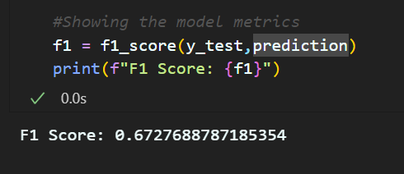
Fig(c): F1 score of the model

- SYSTEM SPECIFICATIONS

  - HARDWARE USED
This project doesn’t need any high-end specifications. It only requires working computer with a minimum of 4GB RAM and a decent processor. The specifications used are listed below:
- RAM – 8GB
- Processor -11th Gen Intel(R) Core(TM) i5-11320H

  - SOFTWARE USED
- VS Code
For the commencement of this project, VS Code has been used, which is a source code editor developed by Microsoft for Windows, Linux, and macOS. Features include support for debugging, syntax highlighting, intelligent code completion, snippets, code refactoring, and embedded Git.

- OUTPUT AND DISCUSSION

  - KEY FINDINGS
The analysis of the result(s) provides several key findings-
        - It was able to accurately classify the news headlines into categories such as positive, negative, or neutral based on the expressed sentiments.
        - NLP combined with ML algorithms enhances sentiment analysis by extracting meaningful patterns from the top news headlines and the stock prices.
        - Identification of the correlation or patterns between the sentiment of news headlines and subsequent movements in stock prices over the period of time.

  - LIMITATIONS
        - One of the major limitations (or challenges) faced while performing sentimental analysis is the imbalance between the positive and negative sentiments.
        - From the given correlation matrix, we can determine the imbalance between the labels 0 and 1, i.e., positive sentiments(i.e. class 1) and negative sentiments(class 0) respectively.
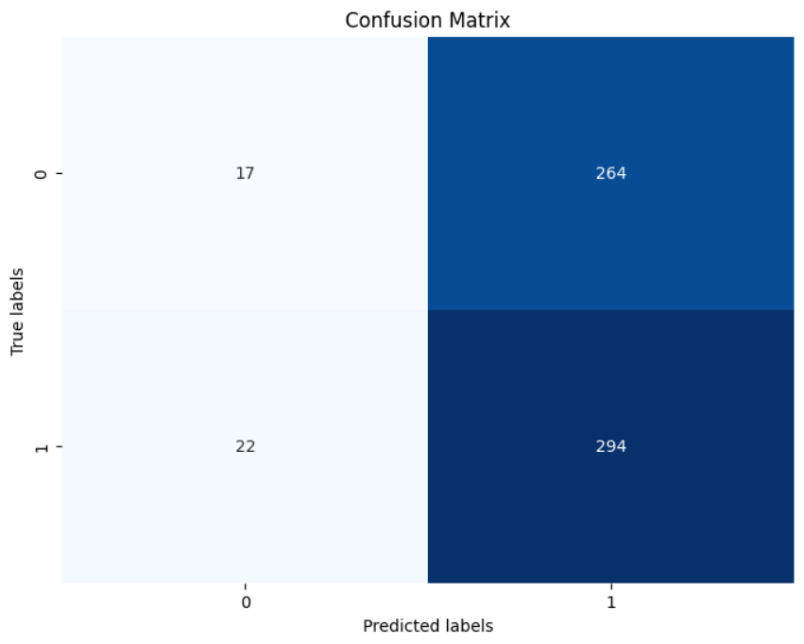

Fig(d): Confusion matrix of the y_test and the prediction set

          - The previously discussed limitation can be resolved by calculating the F1 Score over Accuracy. This approach can be beneficial as if accuracy is used as the evaluation metric, there may be cases where the result may encounter high number of false positives (as according to the above given plot, positive sentiment surpasses the negative sentiments by a very large scale)

  - PRACTICAL IMPLICATIONS AND FUTURE SCOPES
- Enhanced Trading Strategies: Integration of sentiment analysis insights into algorithmic trading systems for more informed and potentially profitable trading decisions.
- Risk Management Solutions: Development of risk management tools leveraging sentiment analysis to identify and mitigate risks associated with volatile market conditions or unexpected news events.
- Investor Sentiment Analysis: Creation of tools for investors to gauge market sentiment and make more informed investment decisions based on sentiment trends and analysis.
- Market Forecasting Tools: Evolution of predictive models combining sentiment analysis with other indicators to forecast market trends and potential stock movements.
- Real-time Sentiment Monitoring: Implementation of systems for real-time monitoring of news sentiment to provide timely insights into changing market sentiments.
- Behavioral Finance Insights: Contribution to behavioral finance studies by examining how sentiment influences market behavior, thus improving understanding of investor psychology and decision-making.
- Risk Assessment in Portfolio Management: Utilization of sentiment analysis to assess sentiment-based risks in portfolio management and optimize investment strategies accordingly.
- Regulatory Compliance and Monitoring: Application of sentiment analysis tools for monitoring and compliance purposes in financial markets to detect potential market manipulation or irregularities based on news sentiment.
- Development of Sentiment Indices: Creation of sentiment indices reflecting overall market sentiment, providing an additional benchmark for market analysis.
- Integration in Financial Services: Integration of sentiment analysis tools into financial services, including trading platforms, robo-advisors, and financial news portals, to offer more comprehensive insights and guidance to users.

- CONCLUSION

In conclusion, our report delved into the intriguing intersection of stock price prediction and sentiment analysis, exploring the potential impact of market sentiment on stock movements. Through a comprehensive analysis of historical stock data coupled with sentiment scores derived from textual data, we aimed to discern patterns and correlations that could aid in making more informed investment decisions.
Our findings revealed a nuanced relationship between sentiment and stock prices. While sentiment analysis demonstrated a capacity to capture market sentiment shifts, it became evident that relying solely on sentiment might not be sufficient for accurate stock price predictions. The stock market is influenced by a myriad of factors, and sentiment, though valuable, represents just one dimension of this complex ecosystem.
The F1 score metrics from our sentiment analysis model provided insights into its efficacy, showing promising results for certain sentiment classes. However, the model's overall accuracy should be interpreted with caution, as the stock market's inherent unpredictability poses challenges for any prediction model.

